Moodle questions – Mechanical properties of materials

Please indicate which statements are true and which are false:

The stress has the units of a force and the strain has the units of a length (F)

The stress has the units of a force per unit length and the strain is a dimensionless quantity (F)

The stress has the units of a force per unit area and the strain is a dimensionless quantity (T)

The stress is measured in Pa and the strain can be expressed as a percentage (T)

Please indicate which statements are true and which are false:

The tensile and the shear stress have the same units (T)

The shear modulus and the Young’s modulus have the same units (T)

The derivative of the stress-strain curve at a given strain is the elastic modulus of a materials at that strain (T)

Stress and strain are always linearly proportional to each other (F)

Please select the correct statement

Plastic deformations are only found in polymers

When a plastic deformation occurs, stress and strain are no longer linearly related

The plastic deformation regime occurs before the elastic regime

The Young’s modulus is constant during a plastic deformation

Please indicate which statements are true and which are false:

What are the characteristic features of a typical strain-stress curve of a “brittle but hard ceramic” compared to the curve of a “ductile and less hard metal”.

The ceramic has a higher yield strength than the metal (T)

The curve for the ceramic has a steeper slope in the elastic regime (T)

The ceramic shows much less plastic deformation than the metal (T)

The ceramic has a lower elastic modulus than the metal (F)

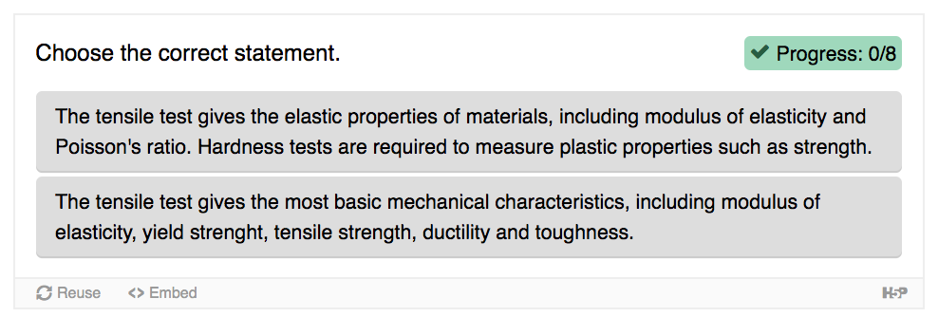Choose the correct statements between these two pairs

(bottom one is the true one)

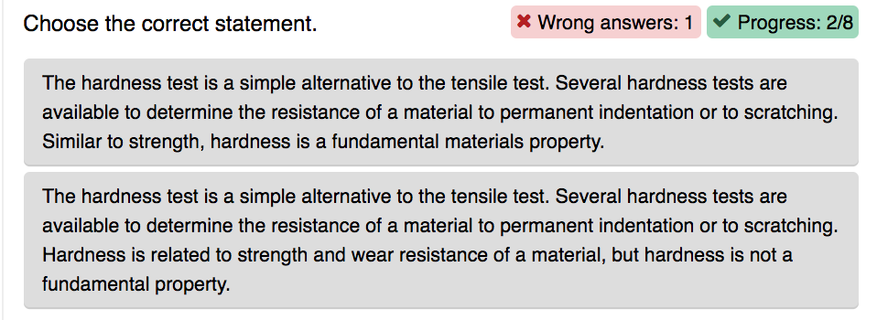

(bottom one is the true one)